Analysis of web application

By

Qinyi Liu

Submitted to

The University of Liverpool

MASTER-OF-SCIENCE-COMPUTER SCIENCE

*CSCK543 Networks and Web Technology October 2023*

Word Count: 500

26/11/2023

TABLE OF CONTENTS

Page

LIST OF FIGURES 3

Chapter 1. Introduction 4

Chapter 2. WEB APPLICATION AND ITS USABILITY AND ACCESSIBILITY 5

2.1 Web application pages 5

2.2 Usability and Accessibility 6

Chapter 3. Conclusions 7

REFERENCES 8

LIST OF FIGURES

Page

Figure 1. Homepage screenshot 5

Figure 2. page 2 “destination” 6

Figure 3. view from different sizes 6

# Introduction

This task is to develop a small website according to a theme of your choice. The theme I chose was traveling to Edinburgh. As per the requirement, this website has two pages, the landing page on my case which is the homepage and a second page called "Destination". The site should include external links, use a single stylesheet and use only HTML and CSS.

# WEB APPLICATION AND ITS Usability and Accessibility

Web application pages

The homepage is shown in Figure 1. homepage includes header, navigation menu, main content and footer. There are three columns in the navigation menu, i.e. homepage, destination, hotel. But the hotel page is empty. The navigation menu has a hover function, so that moving the mouse over it will result in a green underline. On the top left of the homepage is a logo I created for this theme using Canva. In addition, the homepage has two buttons, "more about Edinburgh", which leads to the Wikipedia page for the city of Edinburgh. The "subscribe" button leads to the page of a travel navigation company called Rabbies. Finally, the background image of the homepage is a landscape of Edinburgh. The footer at the bottom indicates the copyright.



Figure 1. Homepage screenshot

Page 2 can be accessed from the homepage navigation menu under 'destination'. page 2 features three of Edinburgh's most popular attractions, each with an external link to the official website of the attraction or its Wikipedia page. In addition, this page contains short text descriptions, audio descriptions and YouTube videos as required.

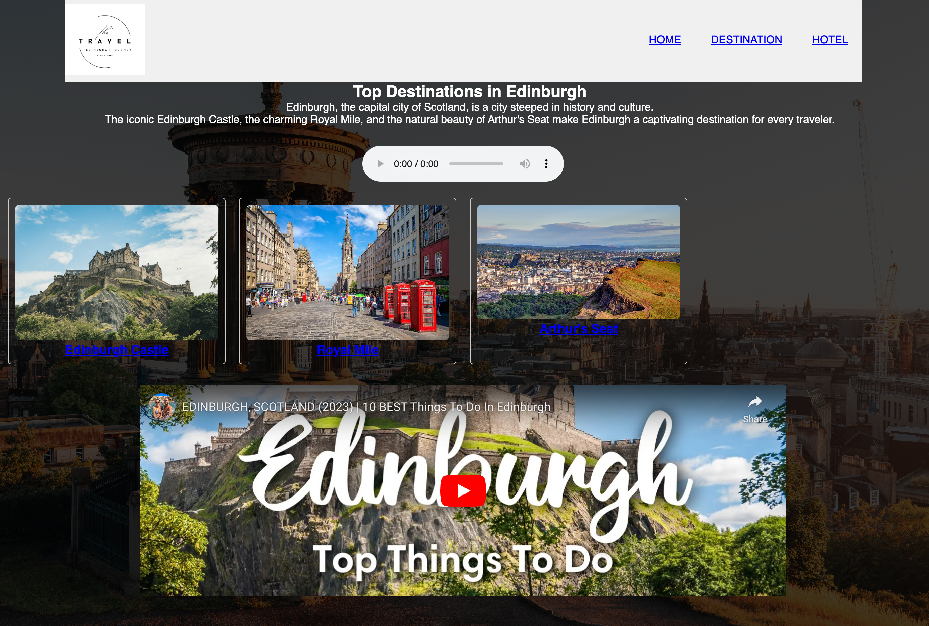

Figure 2. page 2 “destination”

Usability and Accessibility

In order to meet the requirements of the website should be able to adapt well to the requirements of different viewport sizes, in the production of website, this paper adds the following code to ensure that the website in different widths of the instrument is accessed to be able to flexibly adjust after.

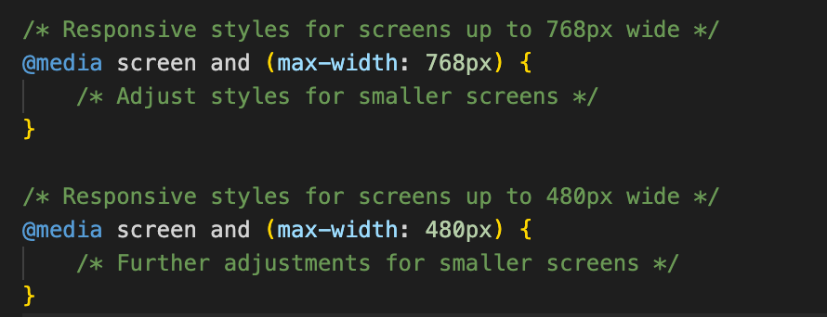

Figure 3. view from different sizes

According to the Initiative (WAI) (2023), websites should have alternative text for users who cannot read images. The images on this website are described in alternative text. Furthermore, the size of the images used on this site is not large, considering that some users' broadband speeds may vary. This problem can be further enhanced by using a content delivery network (CDN), but since this site is not published, it cannot be implement (Cloudflare, 2023). In addition, to improve the readability of the web page, the fonts were created with more contrasting colours on this web page (Initiative (WAI), 2023). Finally, this website has been tested on Firefox, Google Chrome web browser, and Internet Explorer and works well.

# Conclusions

In summary, this site was constructed under the requirements of a midterm assignment with some aesthetic elements (e.g. hover function). The possible limitations of the website are testing issues, as I am using a MAC computer. There may be some minor differences when viewing this page on a windows computer.

REFERENCES

Cloudflare (2023). What is a CDN? | How do CDNs work? | Cloudflare. Cloudflare. [online] Available at: https://www.cloudflare.com/learning/cdn/what-is-a-cdn/ [Accessed 26 Nov. 2023].

Initiative (WAI), W.W.A. (2023). An alt Decision Tree. [online] Web Accessibility Initia-tive (WAI). Available at: https://www.w3.org/WAI/tutorials/images/decision-tree/ [Ac-cessed 26 Nov. 2023].